**EC2 ImageBuilder**

1. **Prerequisites:**
2. **AWS Identity and Access management (IAM)**

The IAM role that you associate with your instance profile must have permissions to run the build and test components included in your image. The following IAM role policies must be attached to the IAM role that is associated with the instance profile:

* EC2InstanceProfileForImageBuilder
* EC2InstanceProfileForImageBuilderECRContainerBuilds
* AmazonSSMManagedInstanceCore

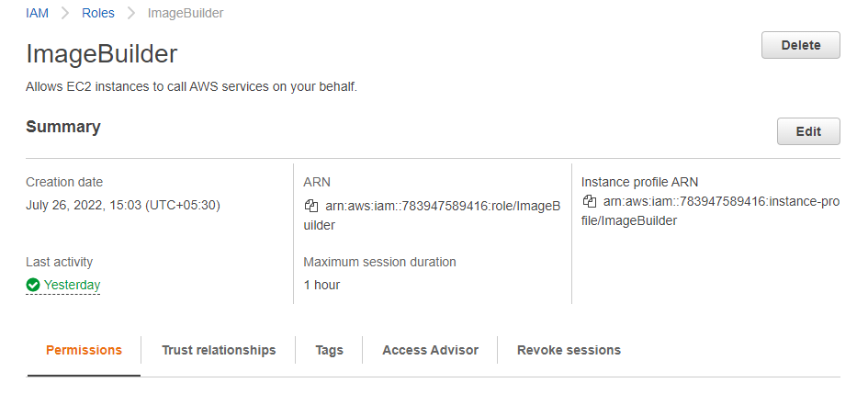

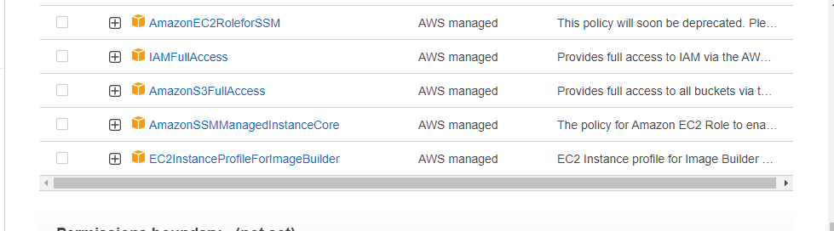

1. **Configuration Requirements**

Image Builder does not install the Systems Manager Agent on Amazon EC2 Windows Server build instances. If your base image did not come preinstalled with the Systems Manager Agent, you must launch an instance from your source image, manually install Systems Manager on the instance, and create a new base image from your instance.

1. **Create an Image Pipeline**

**Step 1 : Specify pipeline details**

1. Open the EC2 Image builder console at [https://console.aws.amazon.com/imagebuilder/](https://console.aws.amazon.com/imagebuilder/" \t "https://docs.aws.amazon.com/imagebuilder/latest/userguide/_blank).

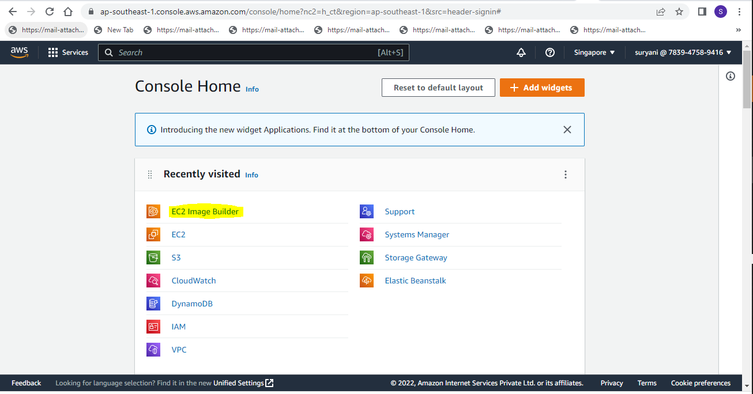

1. To begin creating your pipeline, choose **Create image pipeline**.

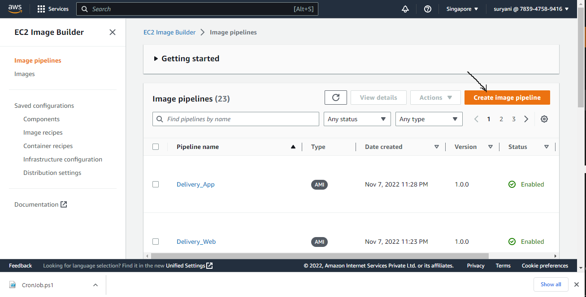

1. In the **General** section, enter your **Pipeline name**.

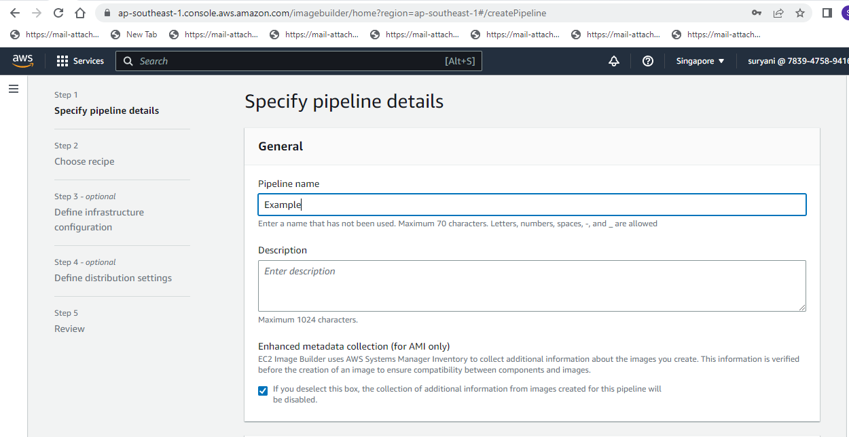

1. In the **Build schedule** section, you can keep the defaults for the **Schedule options**. Note that the **Time zone** shown for the default schedule is Universal Coordinated Time (UTC).

Note : For MOE Project choose Manual option(The pipeline will run when you initiate it.)

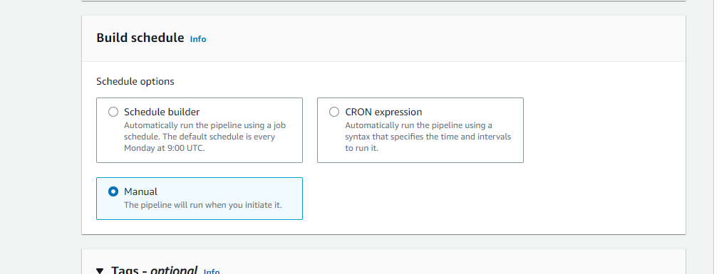

1. Choose **Next** to proceed to the next step.

**Step 2 :Chose Recipe**

1. Choose the create new recipe option.

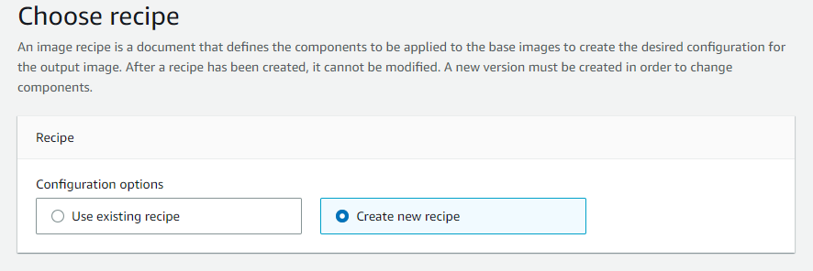

1. Choose the Image type as Amazon Machine Image(AMI).

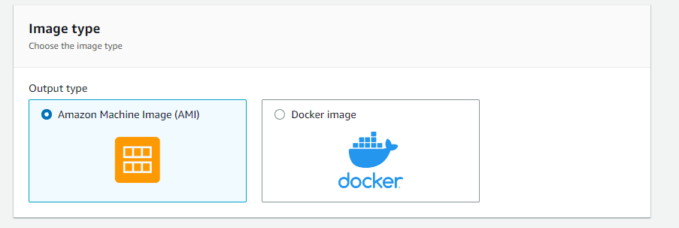

1. Enter the recipe name and version

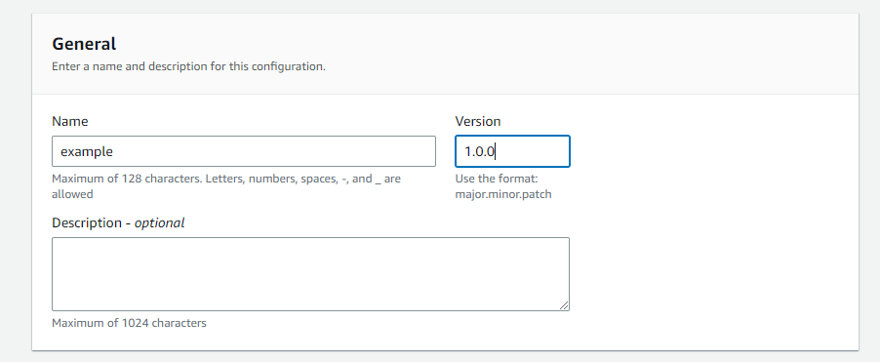

1. For Base image select Enter Custom AMI ID option and enter the base image AMI ID

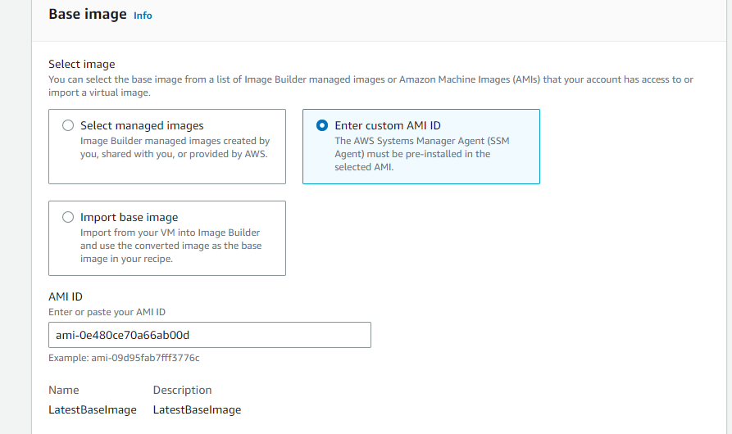

1. In the Infrastructure configuration and Working directory keep the default values.

Note : Keep user data blank

1. In the **Component** section, at least one build component shall be selected

Note : For MOE please choose the component according to the module under the option owned by me. ( Component creation has been explained separately)

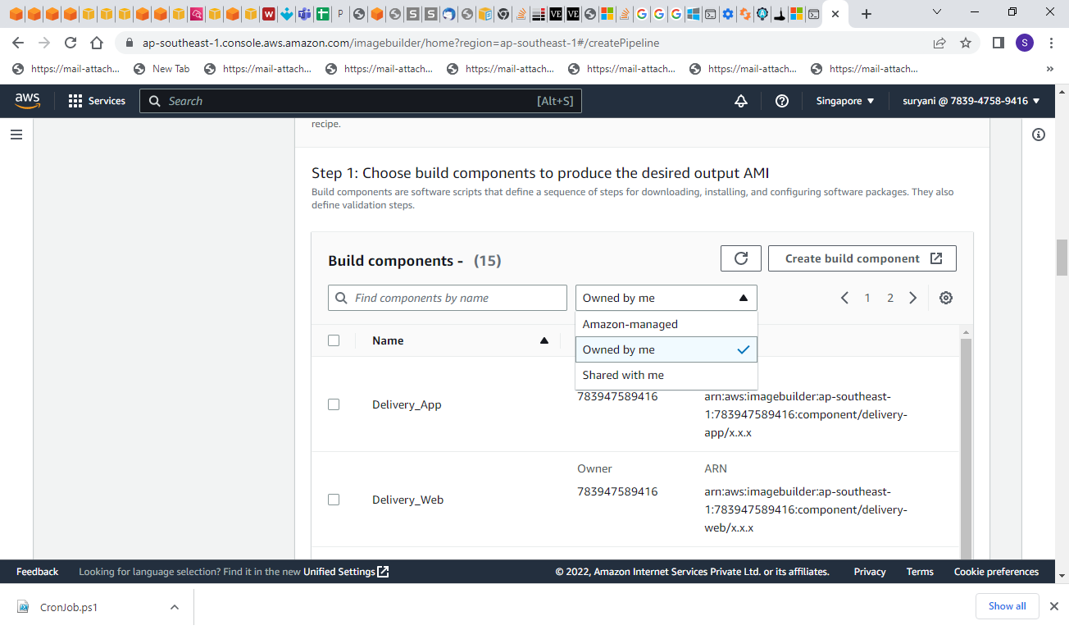

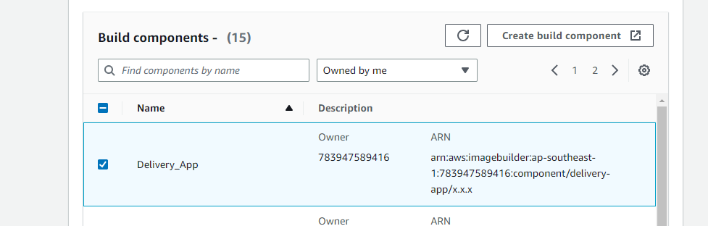

1. In the Test component section select simple-boot-test-windows component

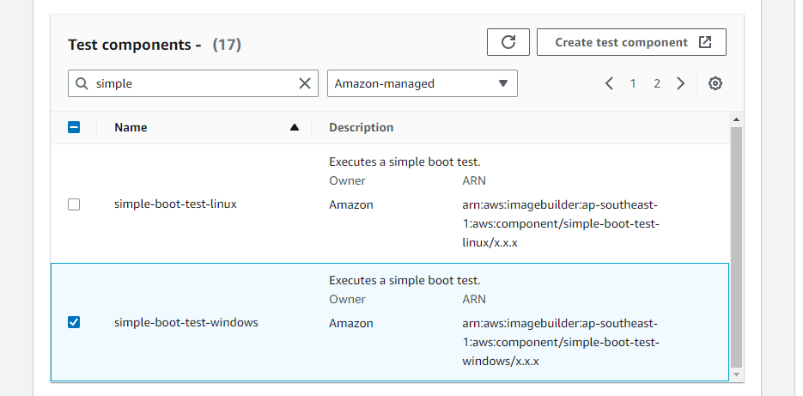

1. Choose **Next** to proceed to the next step.

**Step 3 : Define Infrastructure configuration.**

1. In the Infrastructure configuration section , the configuration options select Create a new infrastructure configuration.

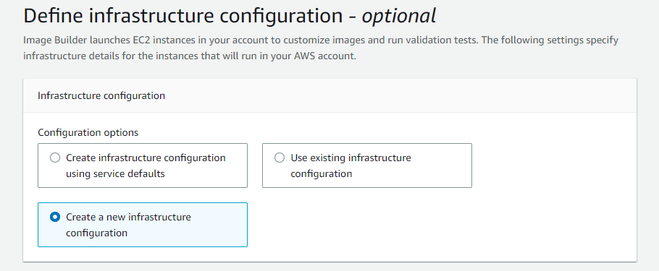

1. In General section Enter the name and Choose the IAM Role which has been created as mentioned in prerequisites section above.

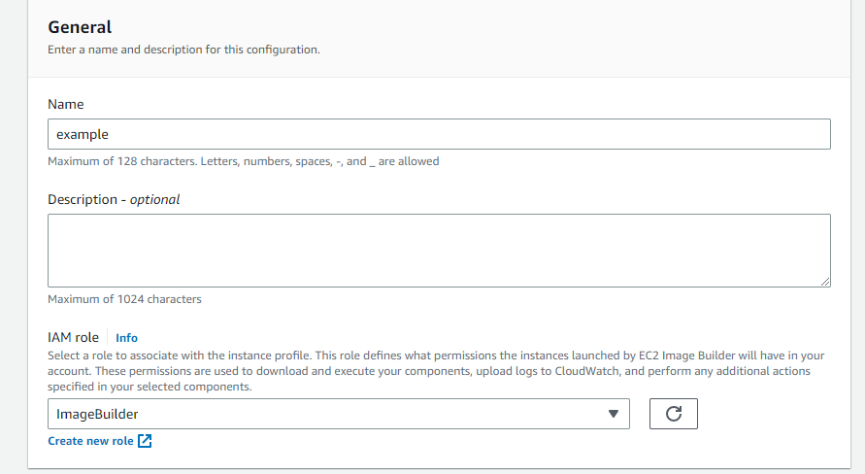

1. In the AWS-Infrastructure option choose Instance type as per the requirement.

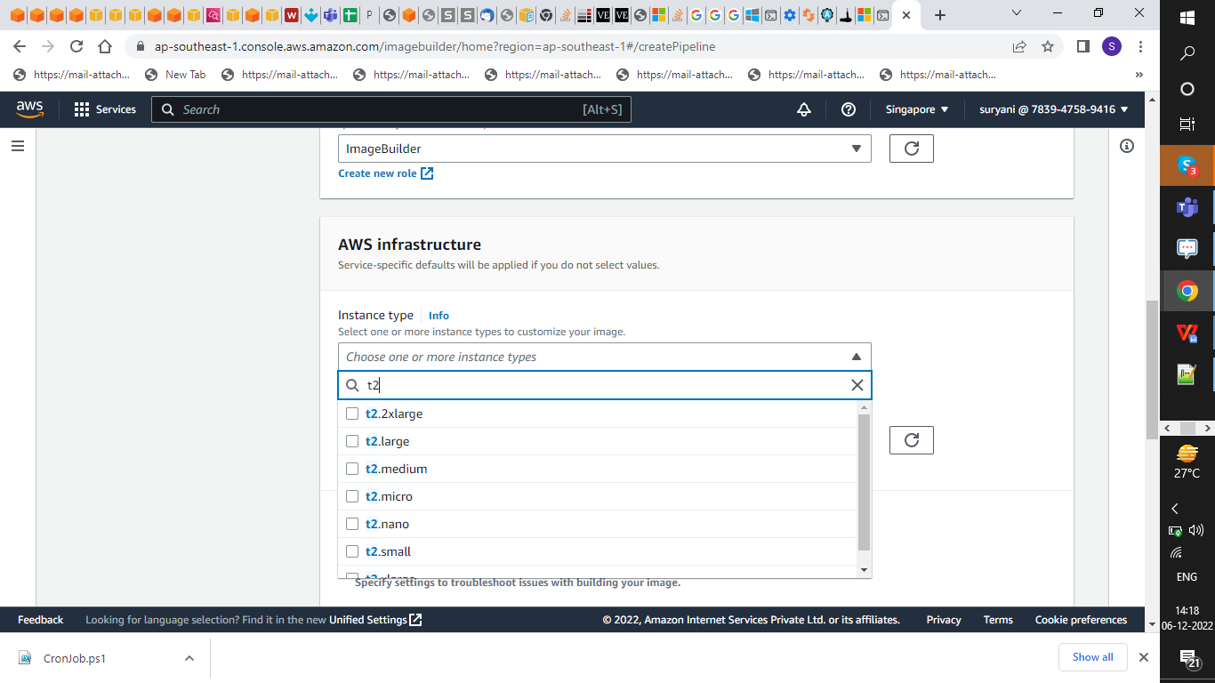

1. Choose **Next** to proceed to the next step.

**Step 4 : Define Distribution Settings.**

1. In the **Distribution settings** section, the **Configuration options** default to Create distribution settings using service defaults. This option will distribute the output AMI to the current Region

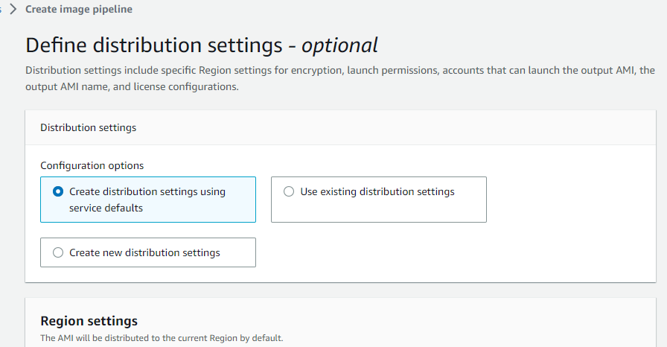

1. Choose **Next** to proceed to the next step

**Step 4 : Review.**

The Review section displays all of the settings you have configured. To edit information in any given section, choose the **Edit** button located in the top right corner of the step section. For example, if you want to change your pipeline name, choose the **Edit** button in the top right corner of the **Step 1: Pipeline details** section.

1. When you have reviewed your settings, choose **Create pipeline** to create your pipeline.

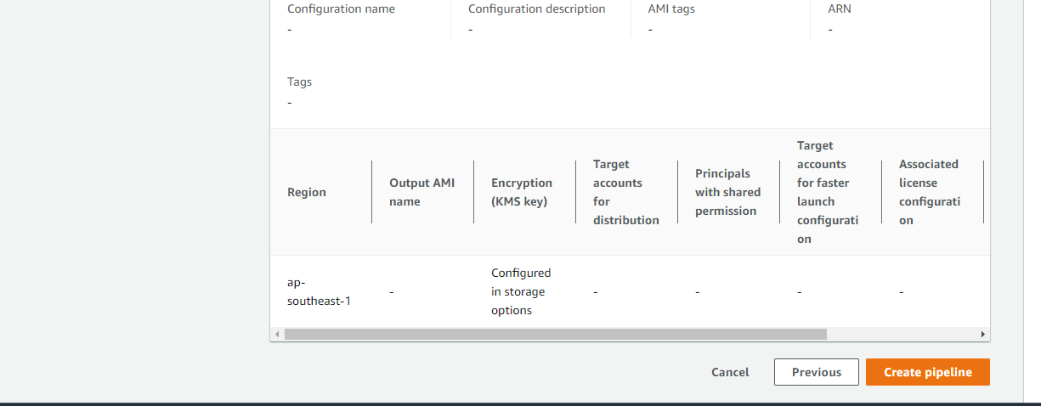

1. You can see success or failure messages at the top of the page, as your resources are created for distribution settings, infrastructure configuration, your new recipe, and the pipeline. To see details for a resource, including the resource identifier, choose **View details**.
2. After you have viewed the details for a resource, you can view details about other resources by choosing the resource type from the navigation pane. For example, to see details for your new pipeline, choose **Image pipelines** from the navigation pane. If your build was successful, your new pipeline is displayed in the **Image pipelines** list.

**3.Component:**

Step 1 : In the Ec2 Image Builder console click on components

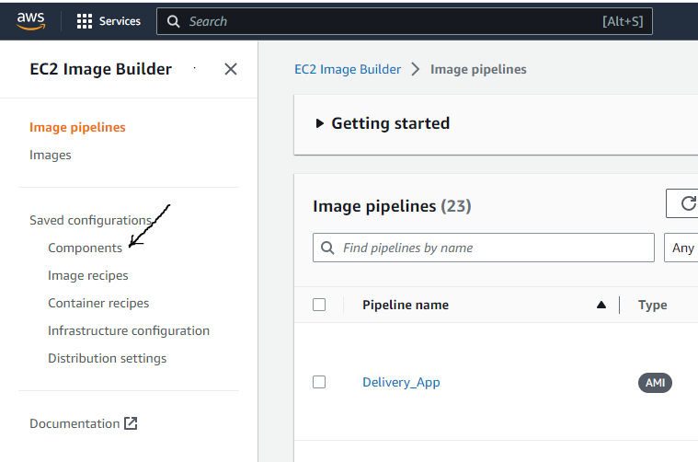

Step 2 : To begin creating your component, click on **Create Component**.

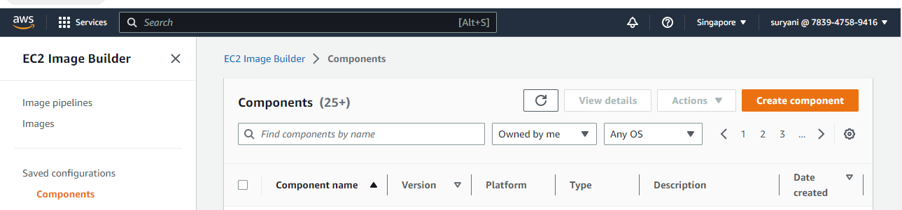

Step 3 : In the Create component

1. In the Component Type choose build

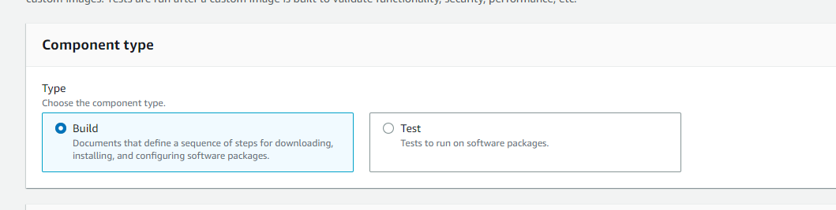

1. In the Component details
2. In the Image Operating System select windows.

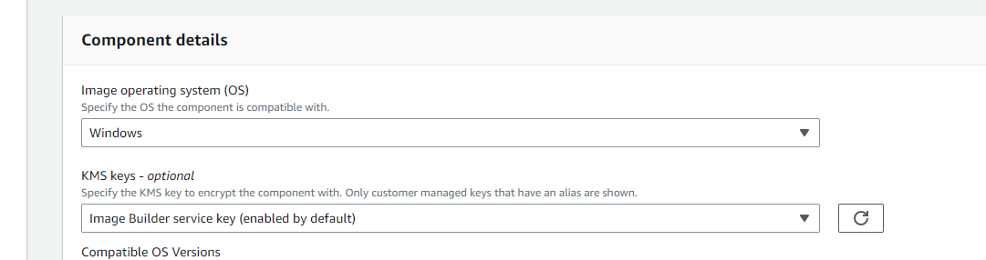

1. Mention the component name and component version

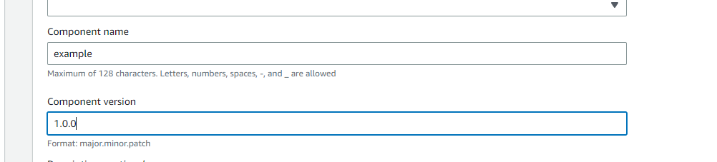

1. In the Definition document
2. Select Use Example

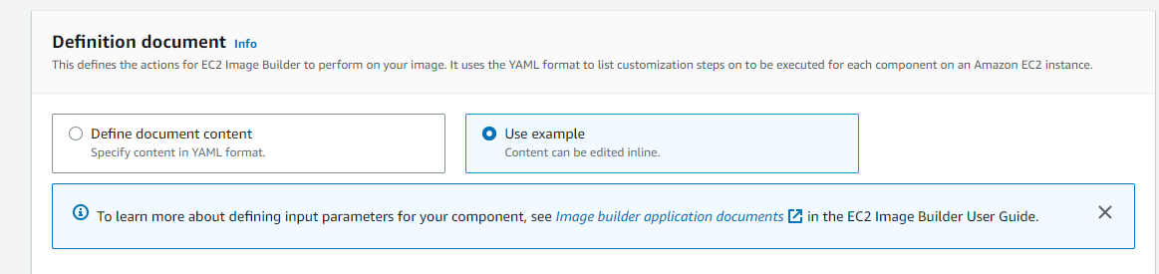

1. Mention the required commands in the Content

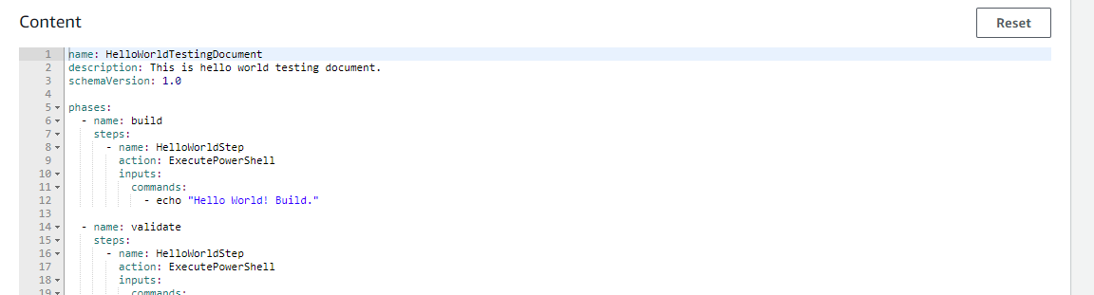

1. click on **Create Component**.

